**FaxCore eV6 Client Print Driver Installation**

**Prerequisites:**

* Windows 10 (all versions), x32 and x64 bit.
* No restrictions for Windows 7 or 8 but there will be no support provided.
* Internet/network access to connect to FaxCore server.
* FaxCore username and password

**Setting up Windows 10 client**

1. To begin installation, run “FaxCore eV6 IP Printer.msi” and follow the on‐screen instructions to complete the installation.
2. <http://downloads.faxcore.com/FaxCore_ev6/Installers/FaxCore%20eV6%20IP%20Printer.msi>

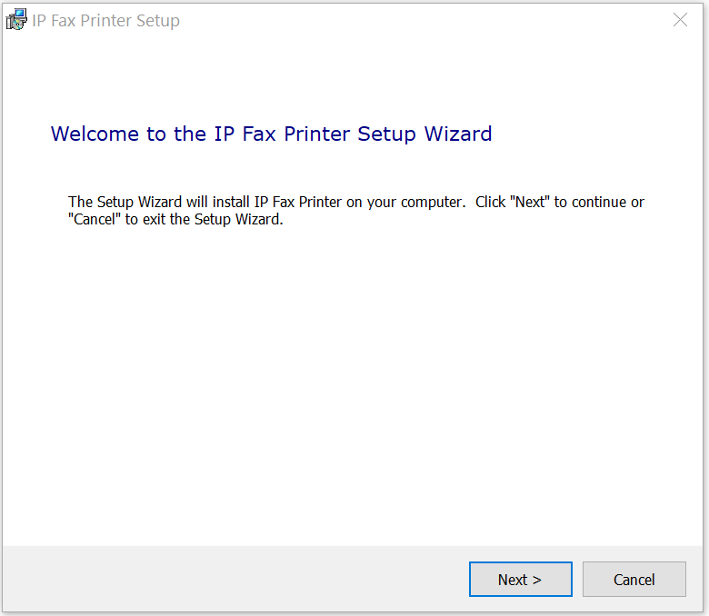

1. Reboot your PC after install is complete.
2. Check in PC Settings “Printer and scanners” that a new printer called “IP Fax Printer” is installed. This icon will appear in your taskbar.

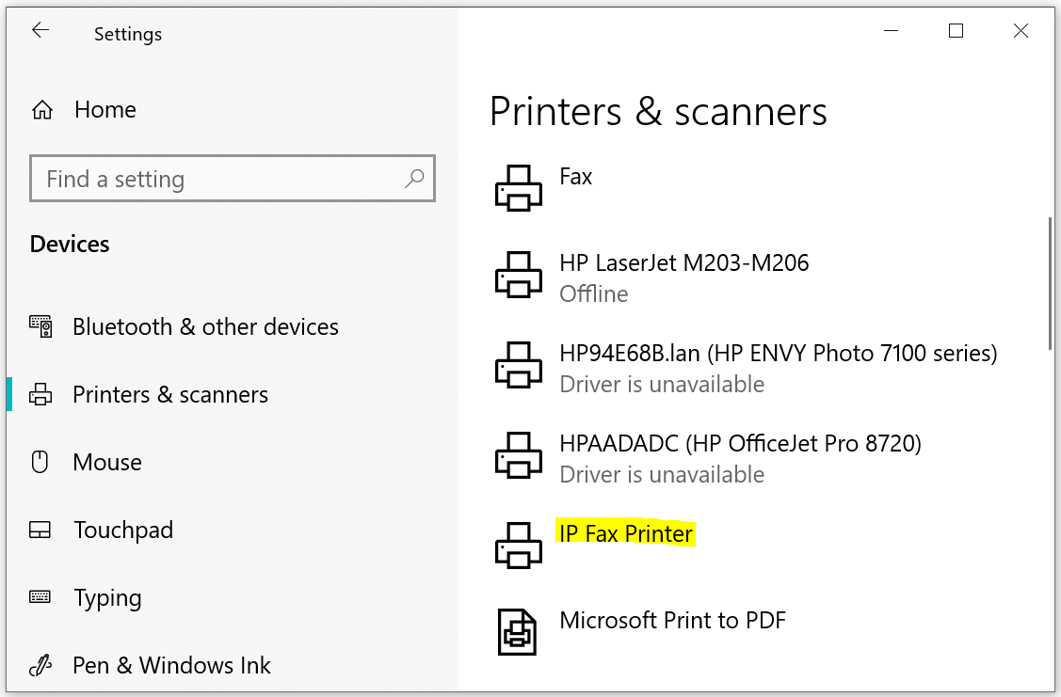

**Setting up the Client Print Driver**

1. To begin using the print driver, open a document to fax and print to “IP Fax Printer”.

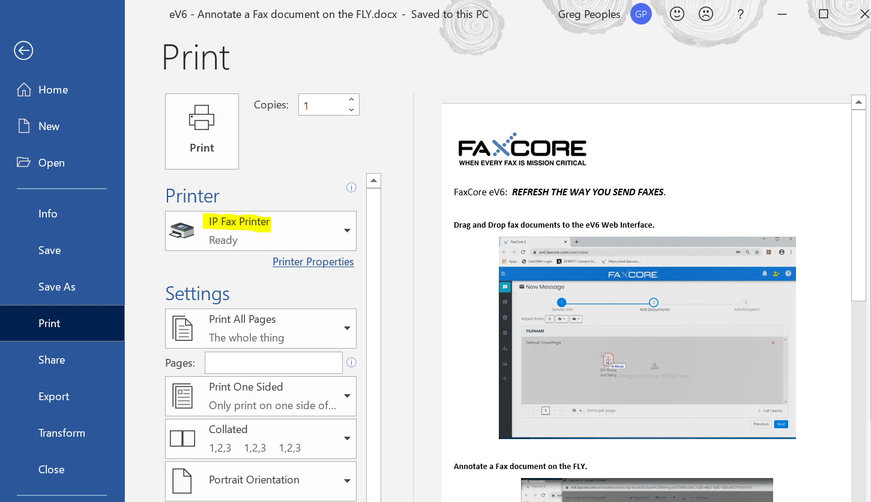

1. The print driver will launch the IP FAX APP.

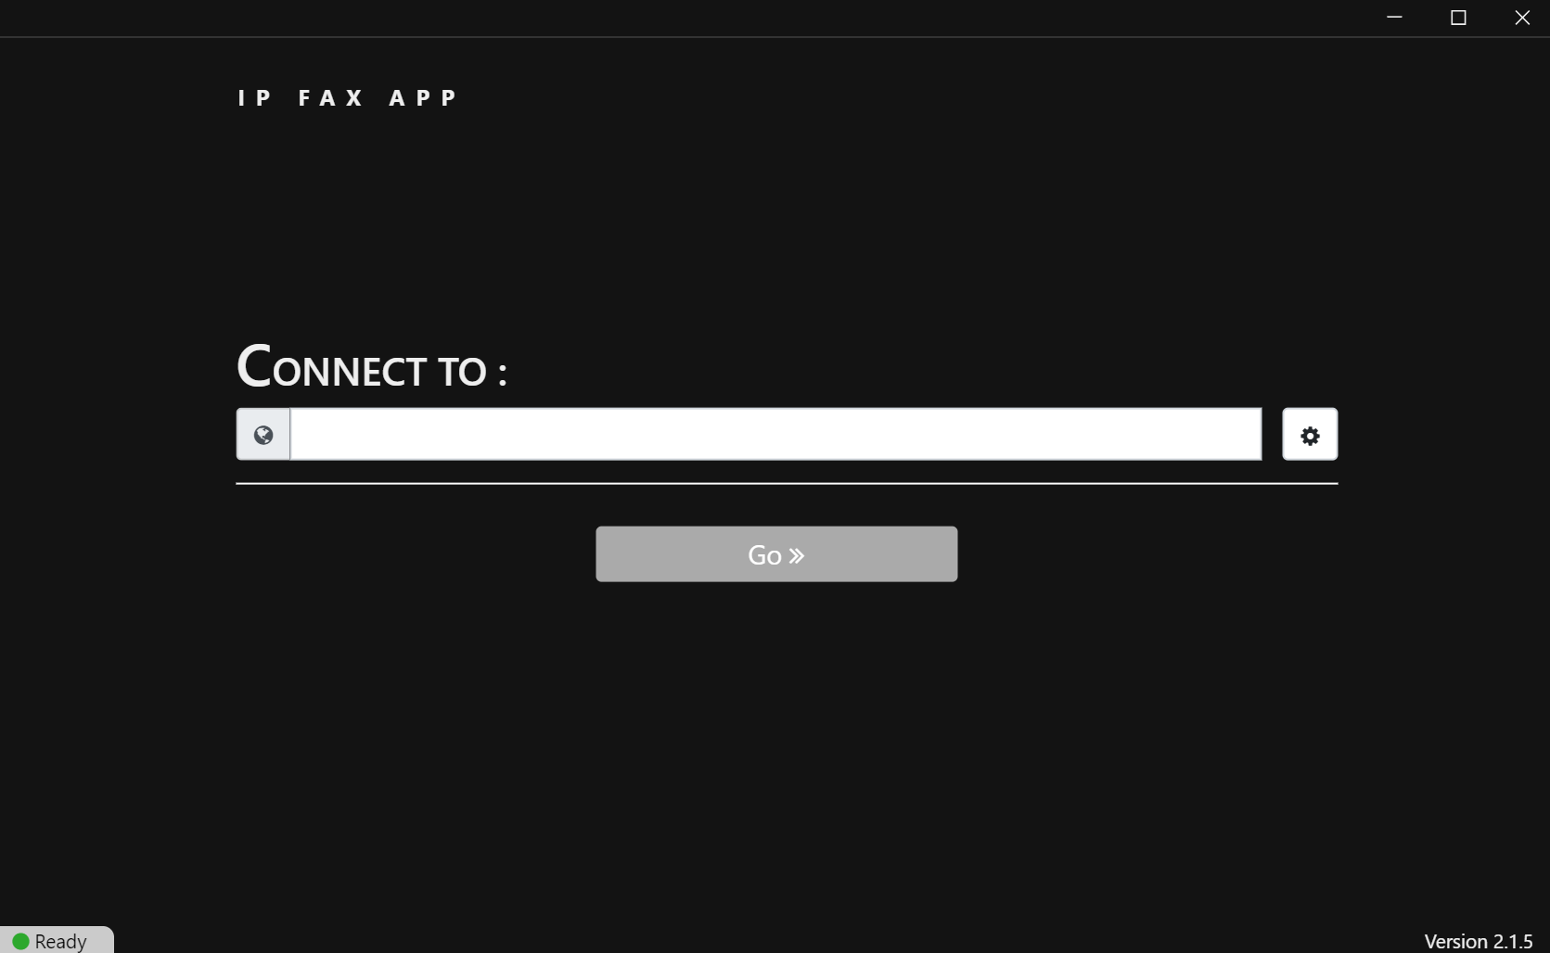

1. Click the configure button & Enter required info. Create a custom Name and use the correct URL for your FaxCore eV6 web server.
   1. Auto-Connect to server? The app will connect to the first profile available.
   2. Auto-close application? The app will close when send is complete.

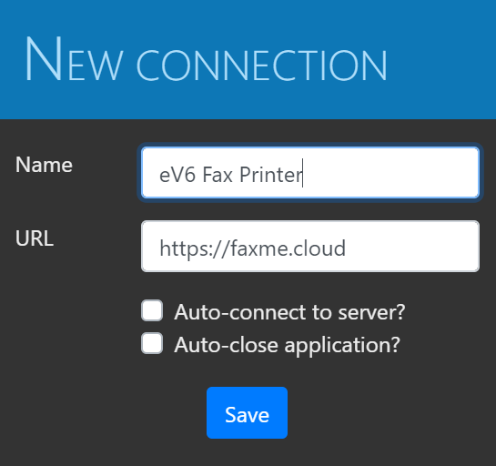

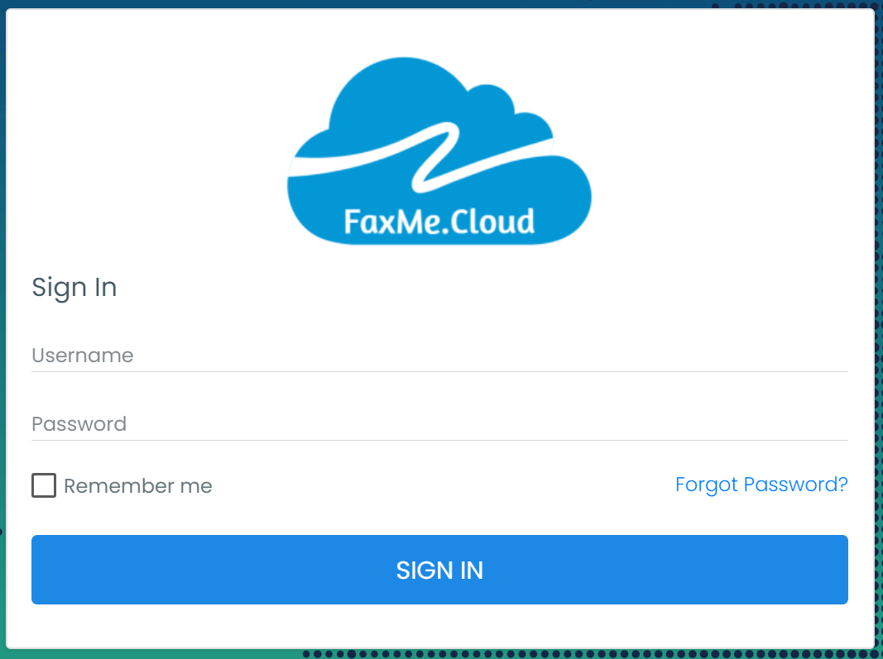

1. After a successful SIGN IN, enter fax recipient NAME and Fax Number are required. More recipients can be added manually or from ADDRESSS BOOK.

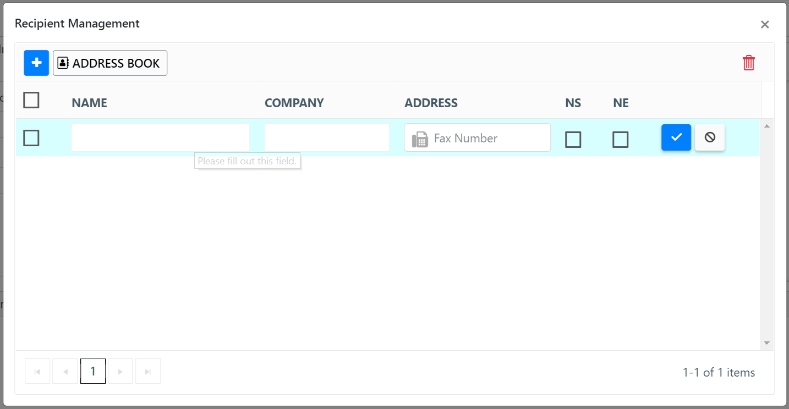

1. Additional information can be added to your fax which will auto populate on the default cover page if desired. Finally click the Send button to finish.

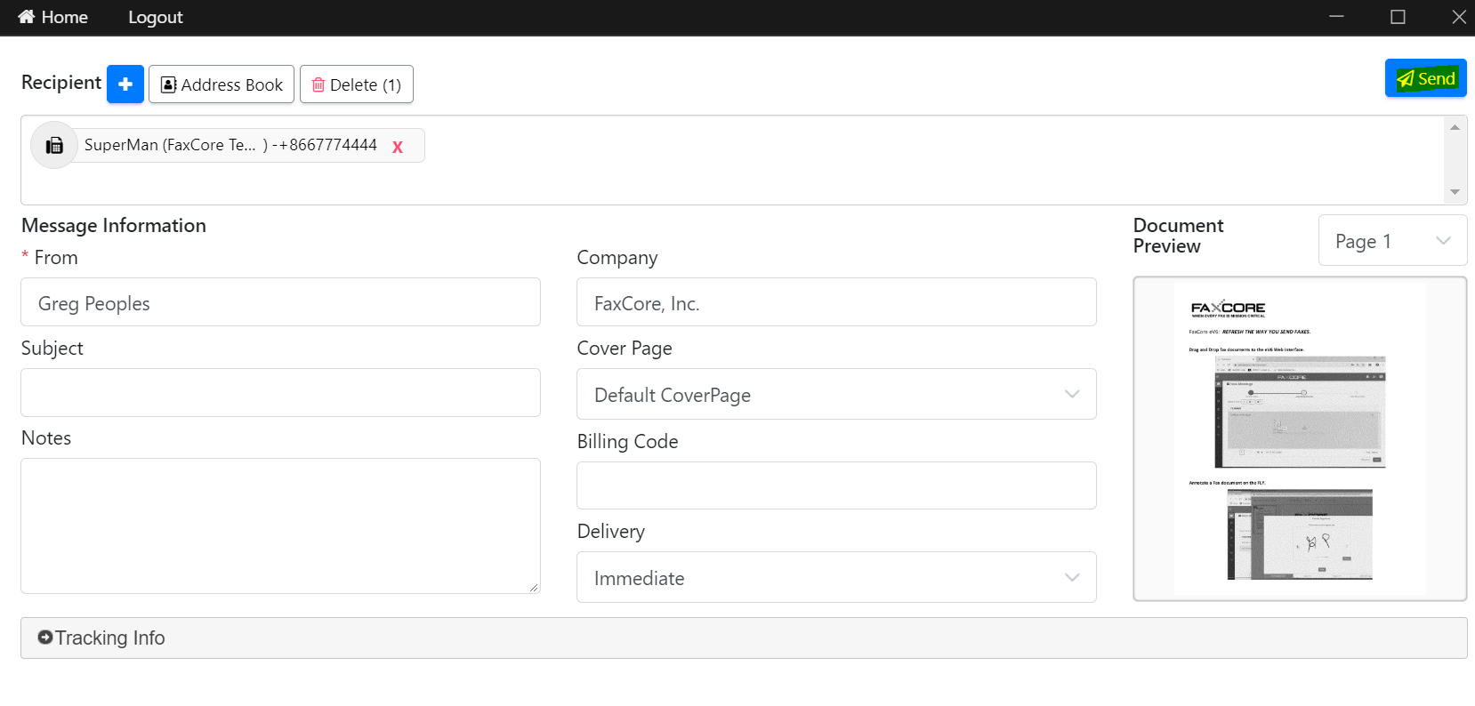

**Switching IP FAX APP to Fax via Outlook**

Simply select “Fax to Outlook” from your Windows toolbar FaxCore tray icon.

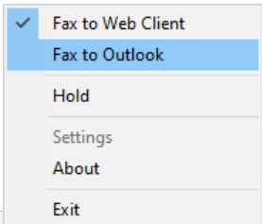

The next fax print job you create will now automatically launch with the Microsoft Outlook client. Enter the fax number you are sending to and append @fax_server_name. (IE: [1234567890@faxme.cloud](mailto:1234567890@faxme.cloud) ).

*Note: This requires the FaxCore SMTPGateway to be enabled on the FaxCore server. Please refer to your FaxCore administrator for more information.*