Here are some cryptic notes on how to install the Sharp OSA 4.0 Connector for FaxCore.

Install Sharp OSA 3.0 <http://downloads.faxcore.com/FC2007/Connectors/FaxCore_Sharp_Connector.exe>

After the install, download [http://downloads.faxcore.com/FC2007/Connectors/Sharp40.zip and unzip to \faxcore\web\Sharp40](http://downloads.faxcore.com/FC2007/Connectors/Sharp40.zip%20and%20unzip%20to%20/faxcore/web/Sharp40)

Modify the \faxcore\web\Sharp40\web.config

                Adding <add key="ScanProtocol" value="scan-http"/> line

                Updating <add key="FaxCoreIP" value="SQLPROD01"/> with the correct IP/DNS location (you can get this from the \faxcore\web\Sharp30\web.config)

                                <add key="ScanProtocol" value="scan-http"/>

                                <add key="FXAPI.wfapi" value="<http://localhost:2372/webservices/wfapi.asmx>"/>

                                <add key="FXDIS.wfdispatcher" value="<http://localhost:2372/webservices/wfdispatcher.asmx>"/>

                                <add key="FaxCoreIP" value="SQLPROD01"/>

                                <add key="FTPServerIP" value="10.0.0.92/sharp"/>

                                <add key="FTPLocalDir" value="C:\faxcore\web\sharp\"/>

                                <add key="FTPUsername" value="anonymous"/>

                                <add key="FTPPass" value="password"/>

                                <add key="defaultUser" value="admin"/>

                                <add key="defaultPass" value="password"/>

                                <add key="EnableExchange" value="true"/>

                                <add key="ExchangeAddress" value="<https://exch.faxcore.com/>"/>

                                <add key="ExchangeFBA" value="true"/>

                                <add key="ExchangeDomain" value="fxc"/>

                                <add key="ExAuthOWA" value="false"/>

                                <add key="EX2007" value="true"/>

                                <add key="SharedKey" value=""/>

From IIS Sites/FaxCore

Right Click on Sharp40 and choose Add Application

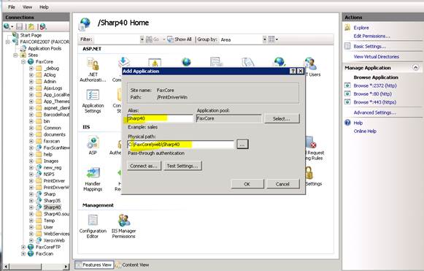

Set Alias to “Sharp40”

Set Physical Path to the Sharp40 directory

Click OK

Copy the following .dll’s from the \faxcore\web\Sharp3.5\bin to the \faxcore\web\Sharp40\bin folder

PegasusImaging.WinForms.BarcodeXpress5.dll

System.Web.Extension.dll

Telerik.Reporting.dll

Telerik.Reporting.HtmlEngine.dll

Telerik.Reporting.Interfaces.dll

Telerik.Reporting.Processing.dll

Telerik.ReportViewer.WebForms.dll

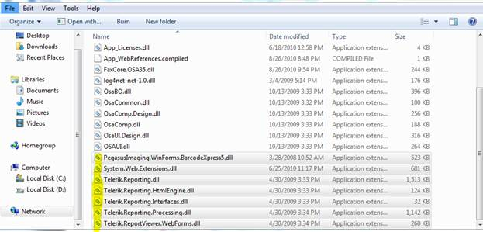

Remote into the Sharp machine.

Applications/External Applications Settings/Fax

Update the Address for Application UI to <http://(faxcore> IP or DNS)/Sharp40/default.aspx

